Practical 5:
Develop a program that executes the equivalent of the shell command: ls -l | grep ".c" using fork(), pipe(), dup2(), and exec() system calls.

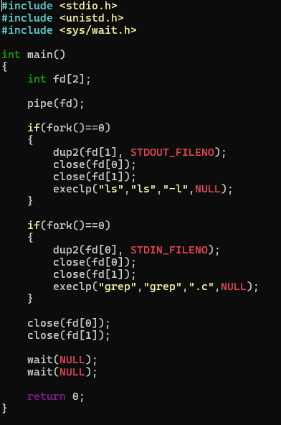

Ouput:
